Station 1-Solving
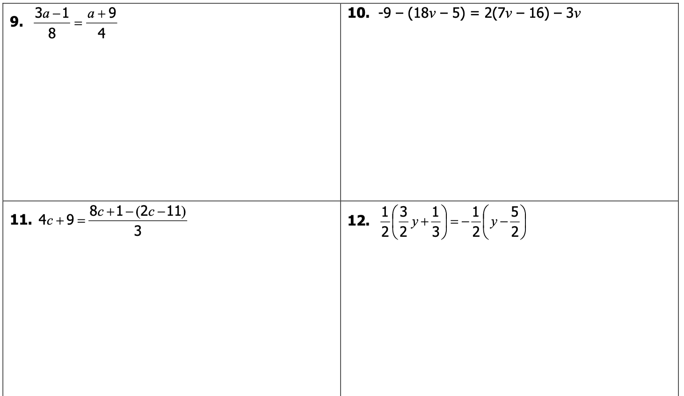

Station 2-Solving
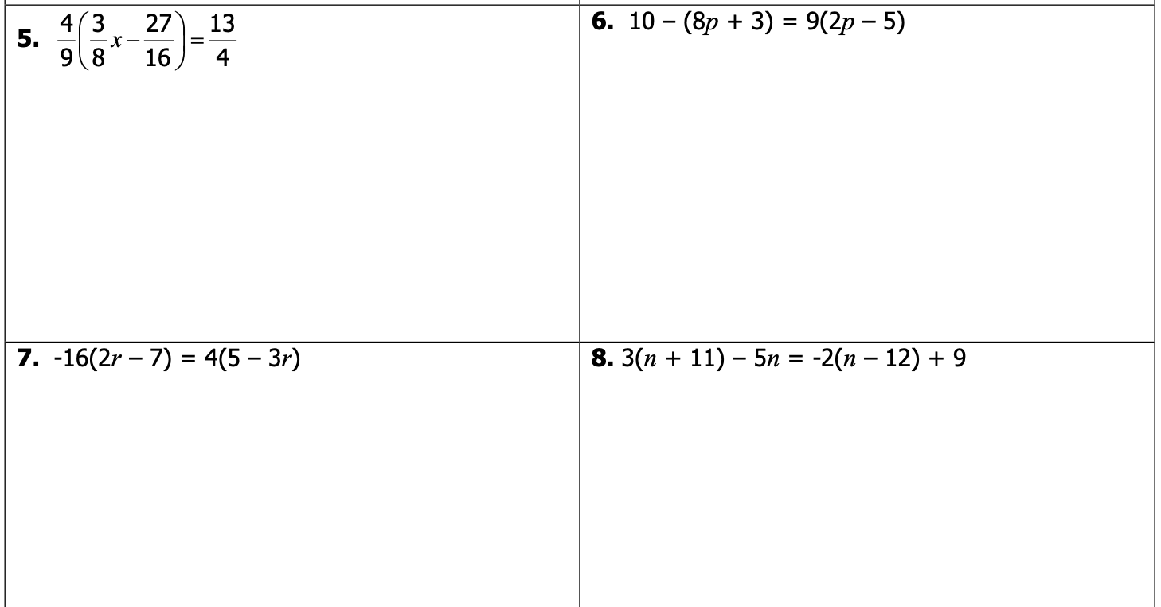
2
2
2
2

Station 3-Word Problems
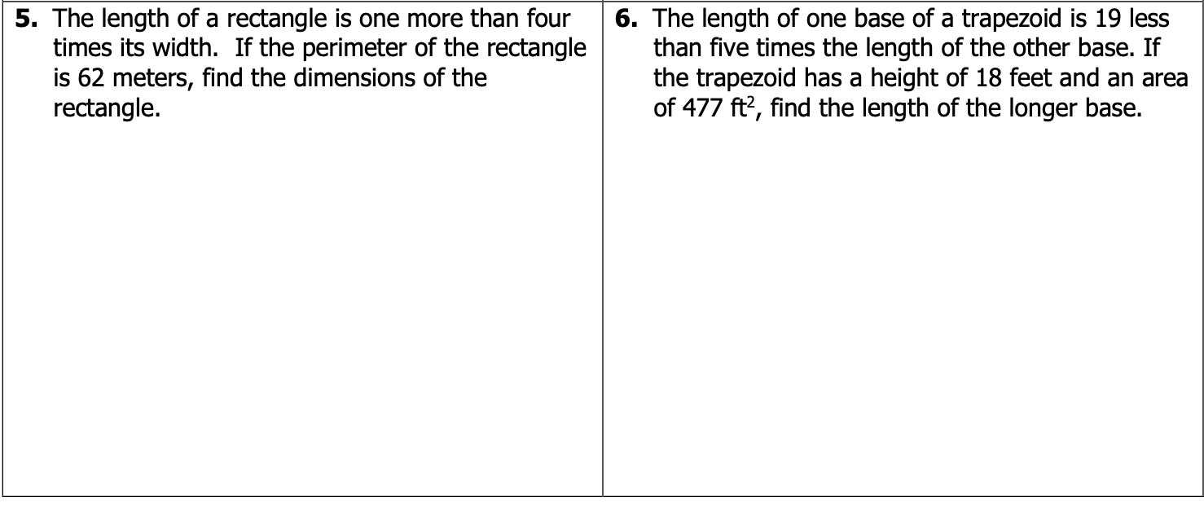
24.

23.

Station 4-Word Problems
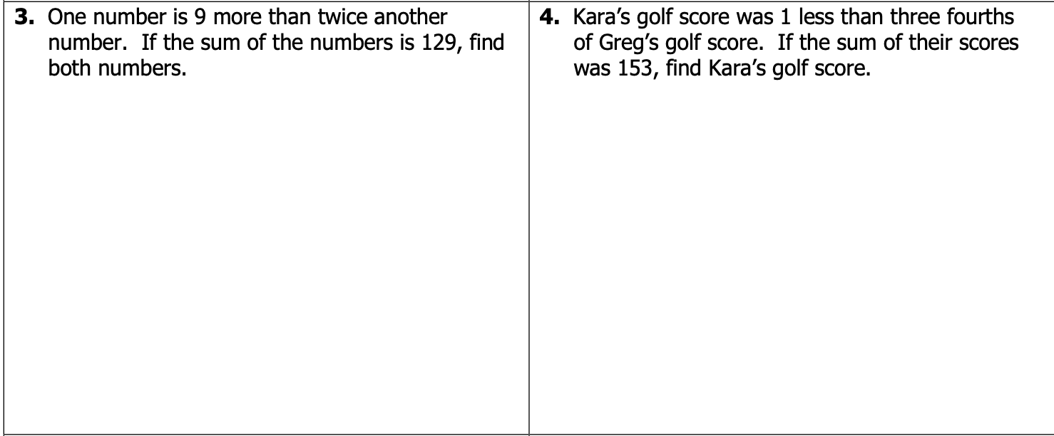

22.
21.

Station 5-Simplify

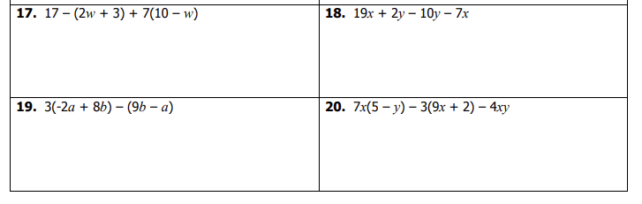

Station 6-Solving
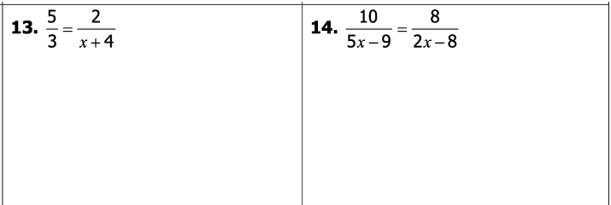
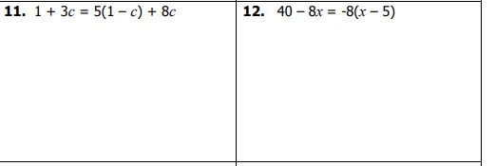

Station 7-Solving
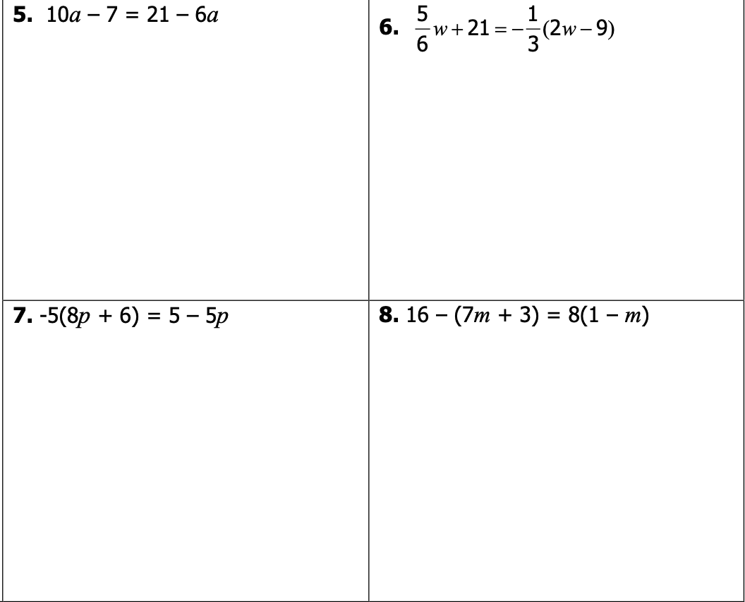

Station 8-Solving
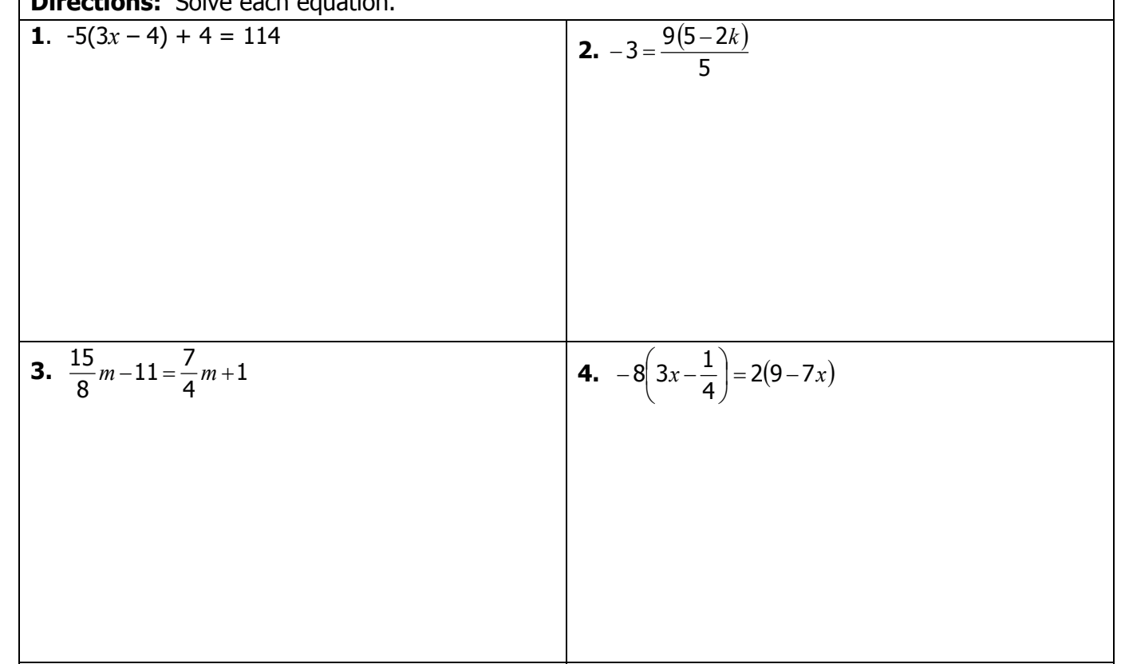

0.1 Stations Answer Sheet
Copy each problem down with the number and show your work.
You have to at least work the FIRST PROBLEM on each station.
The required numbers are listed below.

1. | 5.
9. | 13.
17. | 21.
23. | 25.

S#__P#__ | S#__P#__
S#__P#__ | S#__P#__
S#__P#__ | S#__P#__
S#__P#__ | S#__P#__
S#__P#__ | S#__P#__

S#__P#__ | S#__P#__
S#__P#__ | S#__P#__
S#__P#__ | S#__P#__
S#__P#__ | S#__P#__
S#__P#__ | S#__P#__

